USER AUTHENTICATION USING IMAGE

OBJECT:

Enabling user authentication and accurately verifying an individual’s claimed identity is the first line of defence against unauthorized use of a handheld device.

THIS WEBSITE CONSIST OF 5 MAJOR PAGES / FEATURES:

1. HOME PAGE
2. LOGIN PAGE
3. SIGN UP PAGE
4. ABOUT US
5. VIEW FOR LOGINED USER

TOOLS & SOFTWARE & PROGRAMMING LANGUAGE TO BE USED:

1. PYTHON
2. OPENCV
3. FLASK
4. MYSQL
5. MONGODB
6. DJANGO

SCOPE:

Username and password are the most commonly used mechanism for authentication because of simplicity and convenience.

However it suffers from few drawbacks like selection of weak passwords by the users, users disclosing their passwords etc. This weakens

the security posture of the organizations.

Image user Authentication uses modern machine learning techniques which are quite sophisticated in terms of security. All the registered user’s images are secured in the database.

User’s images are verified using opencv.

Hence we propose a new image based authentication

system which is completely reliable and dependable for security.

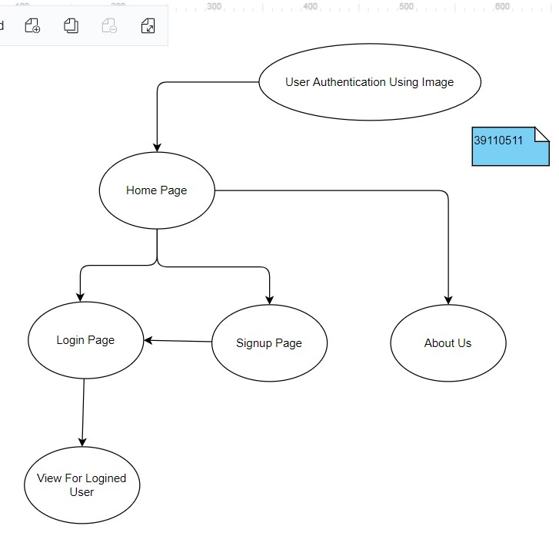

ABOUT HOME PAGE:

THIS PAGE CONSIST OF SOME BASIC INFORMATION, LOGIN, SIGNUP, CONTACT US

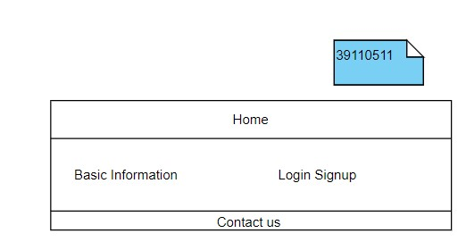

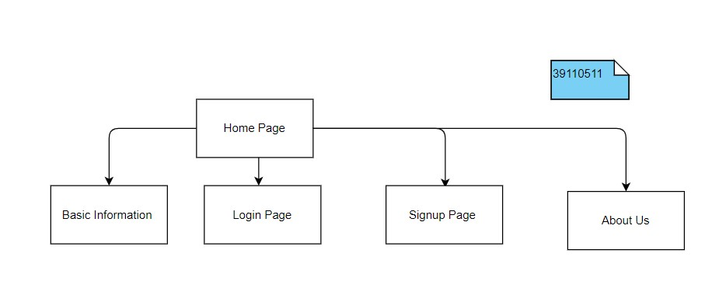

ABOUT LOGIN PAGE:

THIS PAGE CONSIST OF ONE FORM WICH HAS TO VERIFY THE DATABASE FOR THE LOGIN CREDENTIALS OF THE USER IS VALID OR NOT. IF IT IS VALID RETURNS MESSAGE AS VALID USER FOR LOGINED USER. ELSE RETURN MESSAGE AS INVALID USER.

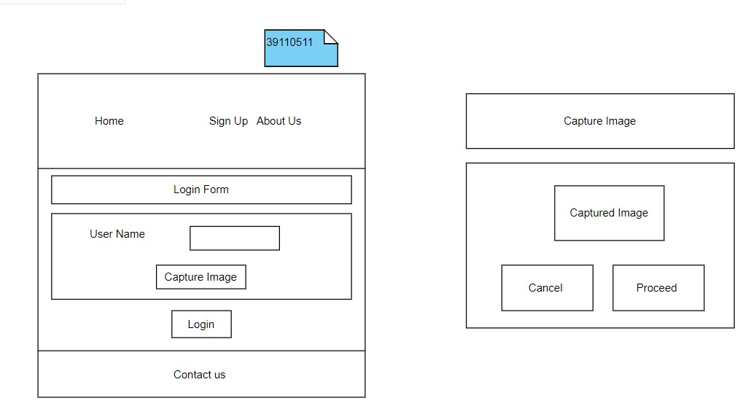

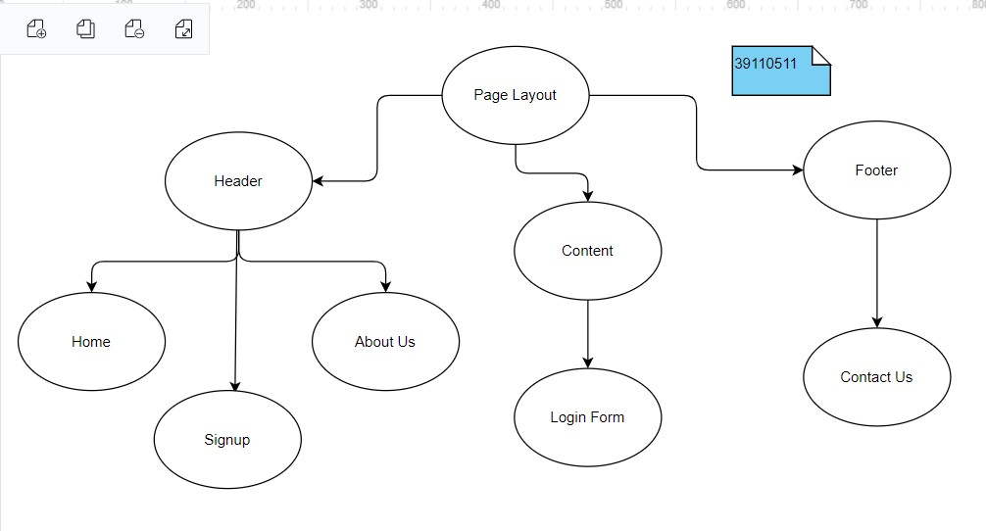

ABOUT SIGNUP PAGE:

THIS PAGE CONSIST OF ONE FORM WICH IS GOING TO TAKE DETAILS OF THE USER.

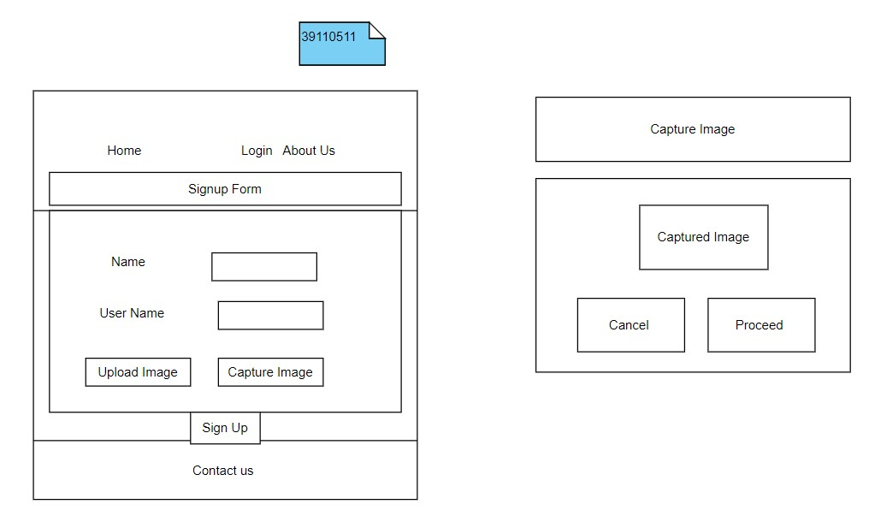

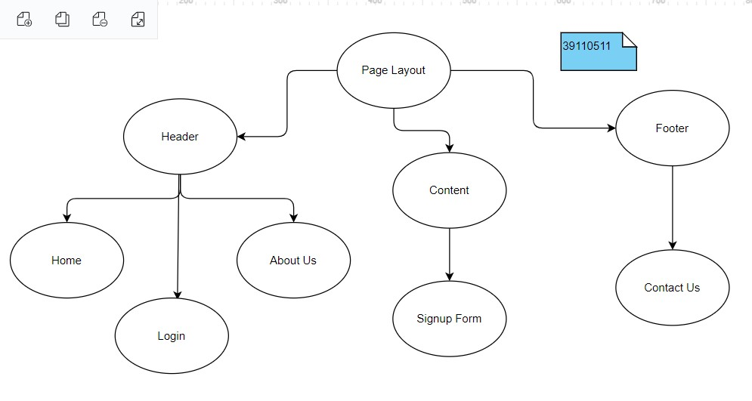

ABOUT US PAGE:

GIVES SOME INFORMATION

